***Project Phase IV***

***On­­­***

**3-D Multiplayer Game(Tic-Tac-Toe)**

**Submitted for the requirement of**

**Project course**

BACHELOR OF ENGINEERING

**COMPUTER SCIENCE & ENGINEERING**



**Submitted to: Priyanka Sharma(E6197) Submitted By: Sahul Kr. Parida(20BCS4919)**

**(Project Supervisor) Saksham Thakur(20BCS4970)**

**Sudhanshu Kumar(20BCS4953)**

**Co-Supervisor Signature**

**Archana Kumari (E13569)**

**DEPARTMENT OF COMPUTER SCIENCE & ENGINEERING**

**CHANDIGARH UNIVERSITY, GHARUAN**

**November 2022**

**Table of Contents**

Detailed System Design/Technical Details

1.1: Introduction 3

1.2: The Methodology 3-6

1.3: Requirement Analysis 7-8

2.1: Game Design 8

2.2: Navigation Map 9

2.3: Storyboard 9

2.3: Chapter Summary 10

REFERENCES 10

**Detailed System Design/Technical Details**

# **1.1 Introduction**

In this chapter, we will discuss the methodology that will be used in developing the game. The methodology is an important element because its act as a guide throughout the game development to produce a complete and functional game. There are several methodology models that can use when to develop a game such as ADDIE and waterfall model.

# **1.2 The Methodology**

The method that can use in game development life cycle followed by a different individual to meet their requirements. In general, GDLC is iterative in nature and GDLC focus on the quality of the product as their prime focus. There is a great area of intersection between SDLC and GDLC, so the benefits provided by SDLC are implicitly inherited by GDLC models.

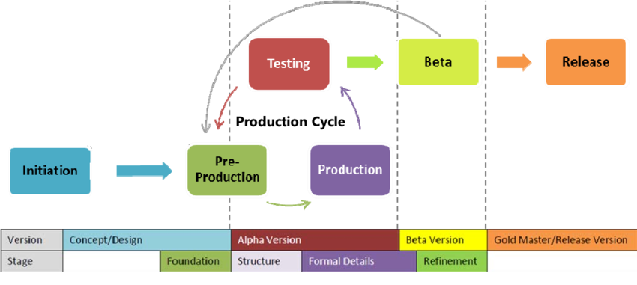

Figure: Game Development Life Cycle (GDLC) Model

GDLC Model is divided into six different phases:

## 1.2.1 Initiation

In this process which involves drafting a high level of the game concept. This phase processes involved: A. Building a story and script

A theme or concept of the game will revolve is defined here. The theme or concept is targeted to an audience of the specific age group. The main and side characters are decided after the plot is defined for every state of the game. The plots of the game divided into the script and it is made there is a continuation of the game from one level to another. B. Feasibility Study

A feasibility study is the possibility to develop the defined game above within the give constraints. All the requirement is gathered such as scope, platform, interface and other.

## 1.2.2 Pre-Production Phase

Pre-production is the first phase of the production cycle. It involves mainly game prototyping and game design. A working prototype of the game is created using the design concept which involves the core feature of the game such as fun elements, layouts, texture, and animation. Various tools used to create design elements are Adobe Photoshop and Adobe Illustrator.

1. Character Design

It is important to design a strong and convincing character that is suitable for the given context and looks visually appealing. Expressions and posture should also match with the theme of the game, especially role-playing game. In this project, the character of the game is drawn manually and convert to 3d model so that the modelling process is easier. The tools used for modelling character is Autodesk Maya.

1. Asset and Materials

Asset and Materials is part of 3d games. It is easier for modeller to put the layout which already have realistic on the texture. Tools used to create the asset is Sketchup. The following are example of asset and materials;

* + Buildings
  + Tree
  + Electric Pole
  + Roads

1. Background Designing

The background design is fully follow the true layout, for example the faculty building, hostel and mosque. The bush and a lot of trees is randomly placed because the design seem same right away.

1. Texturing

The texture is given to increase the realistic of gameplay that can attract the player.

1. Animation

The animation is a process of giving a sequence of action of the character of the game. The flow of the game is not linear mesh methodology is used to give the animation, with the animation we can show the deformations like rib movement, Animation is further classified as motion capture animation and key frame animation.

1. Music and Sound

Apart from animation, music, and tone play a great role in enhancing the overall gameplay. The sound is used to show exaggerate the effect shown in the motion.

**1.2.3 Production**

Production phase comes when the prototype is already designed and approved. It is a process where the actual back end, as well as fronts, end programming is done, game assets are created and merge are together. Here the previously test interfaces are used and if they are not available then they create and add to the existing repository of the interface. The game is actually in a Game Engine which is general purpose game development tools to assist rapid game development. We need to decide which is the programming language and game engine to use in order to implement the code and develop the game. Usually, the 3d game engine that used in game developing is Unity 3d, the programming language used in that game engine is C# and Java. The production phase is also an iterative process in which after each iteration the formal detail like game balancing is refined by adding new features, resolving bugs and improving overall performance. Apart from that game is constantly polished to make it more challenging and fun elements are enhanced.

**1.2.4 Testing**

Testing is an integral part of the software development life cycle and it becomes of utmost importance when it comes to game development. As it has shown from past experience that games are the only software’s in which major bug fixes are reported. Due to the complex nature of the game would run perfectly but when played with intense care it would affect the gameplay. Game testing is performed in a well-structured manner for each and every games ranging from small games to a multiplayer game.

**1.2.5 Beta Testing**

It is performed by the tester outside the development team, a few groups of end users are given the feature complete game for beta testing and the feedback is noted to resolves the bugs. The main feature of beta testing is that the tester can explore every part of the game as the gameplay, music, and animation.

**1.2.6 Release**

In many situations due to some hard deadlines, it is possible to exhaustively test the game. So final version of the game is sometimes released which may contain one or two minor bugs. So the development team then solves the bugs and releases the bug fixes, update and patches for the game that is installed by the ends.

# **1.3 Requirement Analysis**

In developing 3D games, various aspects need to be addressed, among others, in terms of project requirements for the process to run smoothly. The project requirements are software requirements and hardware requirements.

**1.3.1 Software Requirement**

The main software used to develop this game is Unity 3d. This software is required to organized, animate the image and plug in coding to move the character in this game as well as the entire game. In addition, there is other software used in the process of developing this application. The other software used by this game is:

|  |  |  |
| --- | --- | --- |
| No. | Software | Description |
| 1 | Unity | Used to animate the game, scripting Coding and create the platform of the game. |
| 2 | Sketchup | Modelling 3d tools that used to model the asset environment. |
| 3 | Maya | Modelling tools to model, rigging and texturing character. |
| 4 | Abode Fuse | Modelling tools to model, rigging and texturing character. |

Table 3.1: Software Requirements

**1.3.2 Hardware Requirement**

In the process of developing this game, the hardware requirements are also needed. During the development process, hardware and software compatibility is important avoid undesirable problems. Among the tools that help simplify the application development process are:

|  |  |  |
| --- | --- | --- |
| No | Hardware | Description |
| 1 | Intel® Core™ i7-4510u CPU  2.00GHz | Develop the entire game, modelling, editing, scripting programme of the project |
| 2 | External Hard Drive 2 TB | Backup Data |
| 3 | Printer Canon MP258 | For document printing |

Table 3.2: Hardware Requirement

# **2.1 Game Design**

The development of the Sweetness of a Journey game has been using various type of approach. The approach that has been used are:

2.1.1 Instructional Approach

Through this approach, the instruction can give by text usage. The briefing instruction provided to help the user understand the content of this game. The description in this help module also uses the same method and briefly explains the mission that needs to be done by the user.

2.1.2 Help Approach

Through this approach also, users can know about this application by simply reading on the module. In this app also, users are provided with the instruction at the beginning of the game with this, it facilitates the user to understand the game's needs and information.

# **2.2 Navigation map (Data Flow Diagram)**

In developing this project, a navigation map was created to illustrate the continuity between one interface and one another. In addition, the navigation map also serves to give you an overview of what is contained in this project.

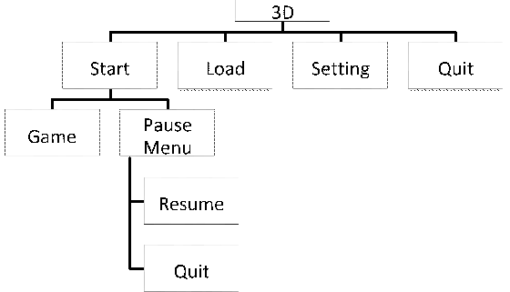

Figure: Navigation Map

# **2.3 Storyboard**

In developing games, storyboard should be prepared in advance before the application of this game. It is very important to facilitate the development of this application as a reference and it is used so that it is in line with the navigation map made. The storyboard is based on story that usually happen inside the campus. With this storyboard, the entire interface can be built from the beginning to the end.

# **2.4 Chapter Summary**

This chapter fully describes the methodology that used to develop the game, software and hardware requirement for this game, the approach used in this game, the navigation map to show the continuity the interface and the storyboard to show the flow game and the proof of the concept of this game. The GDLC is chosen based on the complexity of the game through the developing process. In the game design, it shows the navigation map. Navigation map used to show the flow of the game design starts from the main menu interface.

# **REFERENCES**

1. Mukherjee, Souvik. “Introduction: Video Games and Storytelling.” Video Games and Storytelling, 2015, pp. 1–21., doi:10.1057/9781137525055_1.
2. “Embodying Character in Storytelling.” Performing Story on the Contemporary Stage, 4 Feb. 2013, pp. 9–10., doi:10.1057/9781137356413.0005.
3. Huber, Amy M. “Visual Storytelling.” Telling the Design Story, pp. 101–129., doi:10.4324/9781315226132-6.
4. Pitcher, Jenna (9 October 2013). "Grand Theft Auto 5 smashes 7 Guinness World Records". Polygon. Vox Media. Archived from the original on 9 October 2013. Retrieved 9 October 2013.
5. Jackson, Leah B. (June 9, 2014). "E3 2014: The Sims 4 Release Date Announced". IGN. j2 Global. Retrieved June 9, 2014.
6. Wagner, Jayce (June 13, 2017). "In The New 'God of War 4' Trailer, Kratos Is Old, Grizzled, And as Brutal As Ever". Digital Trends. Designtechnica Corp. Archived from the original on April 13, 2018. Retrieved June 22, 2017.